Food tourism
Diego Guillen
January 23, 2018
- Introduction
  - Background
Food tourism is a growing industry. Over the last years, its industry size has almost double. Some people like to travel to new cities just to taste new flavors and get new culinary experiences. It is particularly important for this kind of tourist to find a wide variety of restaurants around the center. Foursquare can help to identify the next travel destination. By leveraging the information from their database, it is possible to identify if multiple restaurants are in a walking distance between each other, so that the tourist can easily jump from one to the next one.
  - Problem
Food Tourists need support identifying to, which to travel next to get the best culinary experience possible.
- Data acquisition and cleaning
  - Data Source - Foursquare
According to their own description, “Foursquare is the most trusted, independent location data platform for understanding how people move through the real world”. The data will be retrieved by queries from Foursquare server. Information of up to 50 restaurants around the city center will be retrieved via JSON messages. These JSON messages contain relevant information such as location of the restaurant and what type of food they serve. These parameters are the ones that will be used for analysis. The defined walking distance is 1km, and this information is also passed in the query.
  - Data cleaning
The JSON responses contain much more information than required. Therefore, only the most relevant data for this project will be used. Non numeric values are filtered out. This is done by inspecting which type of variables the DataFrame column have.
Table 1. Simple feature selection during data cleaning.
Kept features | Dropped features | Reason for dropping features
Name, categories, lat, lng, city, state, id | LabeledLatLngs, distance, cc, country, formattedAddress, address, postalCode, crossStreet | Not required for this exploratory analysis

- Methodology
First restaurant in Dallas and New York data will be collected. This data will be transformed into DataFrame for easy analysis. To get insights on the data, it will be visualized in a suitable format. Also, the DataFrame will be transformed as required. This is part of the exploratory research that will be performed. Then the results will be presented and a discussion will be provided. Finally a conclusion will be written.
- Exploratory Data Analysis
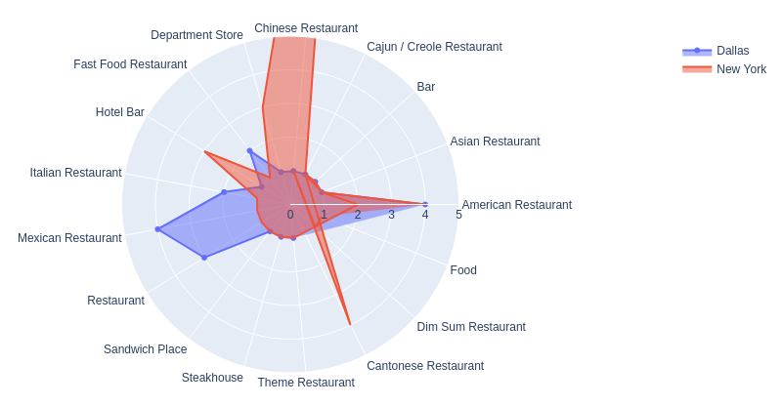
Image 1: Distribution of restaurants per city.
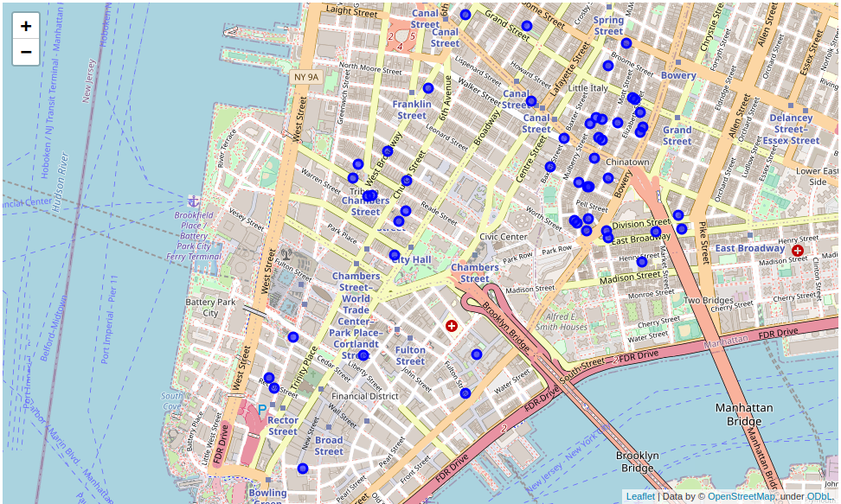
Image 2: Location of restaurants around New York city center.
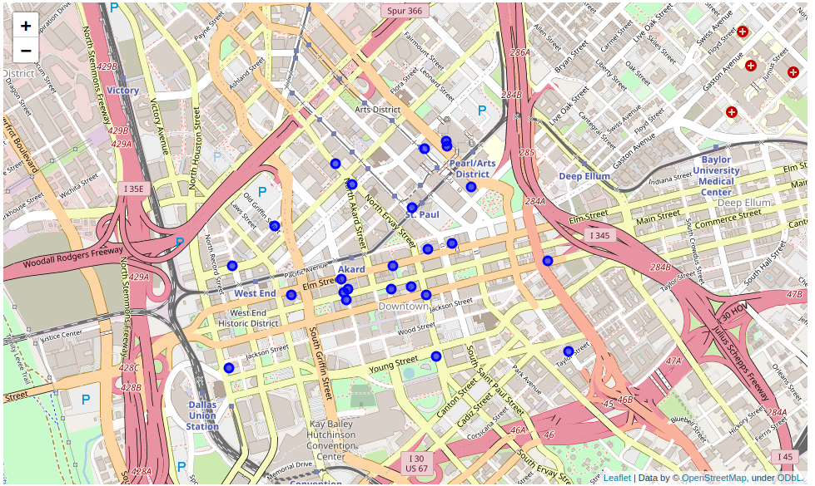
Image 3: Location of restaurants around Dallas city center.
- Results
  - It is possible to appreciate a large number of Chinese restaurants in NY, while Dallas has a larger number of Mexican restaurants.
  - The location distribution of the restaurants if both cities is different. On one side, NY is a very dense area, while in Dallas the restaurants are more distanced.
  - There are more restaurants in the city center in NY than in Dallas.
  - There are more variety of Food in NY than in Dallas.
- Discussion
  - New York has a higher population density and this is also reflected in the restaurants. For this reason, there are plenty restaurants around 1km the city center. This is a great opportunity for a food tourist who want to visit multiple restaurants on a single afternoon.
  - For the same reason that NY is denser, there might be a bias on the data retrieved since it was 1km around the city center. There are more restaurants in this area than in Texas. Therefore, it might have been better to get the 50 closes restaurants to the city center, rather that limiting the search to 1km.
- Conclusions
To conclude, New York is a more attractive city for doing this kind of food tourism, since there are plenty of restaurants in a walking distance from each other. To do the same kind of tourism in Dallas, it is required to use a car.

